## Data Description

### NATO Ukraine IED Incidents Data

This is a NATO Unclassified IED events spreadsheet from the NATO C-IED COE. It contains 665 events, with 15 in 2001-2013, about 230 in 2014 and the rest in 2015. It contains the following column headers: Date, Type, KIA (Killed in Action), WIA (Wounded in Action), City, Region, Country, Details, Group, Remarks. There are missing values in the dataset. Table 1 below provides a sample of the data for December 2015.

*Table 1: Sample of the Ukraine IED incidents data for December 2015.*

|  |  |  |  |  |  |  |  |  |  |
| --- | --- | --- | --- | --- | --- | --- | --- | --- | --- |
| **DATE** | **TYPE** | **KIA** | **WIA** | **CITY** | **REGION** | **COUNTRY** | **DETAILS** | **GROUP** | **REMARKS** |
| 2015 DEC 09 | CACHE/FOUND | 0 | 0 | Kramatorsk | DONETSK | UKRAINE | IEDs were found and disposed by Combat Engineers |  | TBC if they were just landmines |
| 2015 DEC 09 | UNKNOWN | 0 | 0 | Kharkiv | KHARKIV | UKRAINE | An IED was blown up in front of a ROSHEN shop |  | Shopping Center |
| 2015 DEC 08 | UNKNOWN | 0 | 0 | Kiev | KIEV | UKRAINE | A device was detonated against a restaurant (L'Kafa) |  | Boulevard Lesi Ukrainian |
| 2015 DEC 07 | HOAX/FALSE | 0 | 0 | Ivano-Frankivsk | IVANO-FRANKIVSK | UKRAINE | Call reporting IED - First Responders action - no explosive |  | Central Metro/bus station |
| 2015 DEC 02 | CACHE/FOUND | 0 | 0 | Krasnoarmiisk | DONETSK | UKRAINE | An IED was found and disposed by EOD |  |  |
| 2015 DEC 02 | CACHE/FOUND | 0 | 0 | Avdeevka | DONETSK | UKRAINE | A cache with 3 IEDs with TNT was found and cleared |  | Inside an abandoned house |
| 2015 DEC 02 | UNKNOWN | 0 | 0 | Uzhgorod | ZAKARPATS'KA | UKRAINE | An IED was detonated against a store in Franko Street |  |  |

### Ukraine Census Data

We also want to include various statistics about Ukraine to see if we can find patterns between the IED events and these statistics. The data was cleansed and transformed in order to have the same grain and use the same common attributes as our primary data set (the NATO IED dataset). Transformations applied in order to facilitate the data merge with the other datasets: removed irrelevant data from the data set, converted all fields to the correct type, translated the region names to the ones used by the primary data set. The tool used to facilitate these transformations was Microsoft Power BI Desktop Designer.

1. Ukraine population by region and settlement type, as per January 1, 2013. The data was obtained from the Ukraine Census website <http://database.ukrcensus.gov.ua/MULT/Database/Census/databasetree_en.asp> ):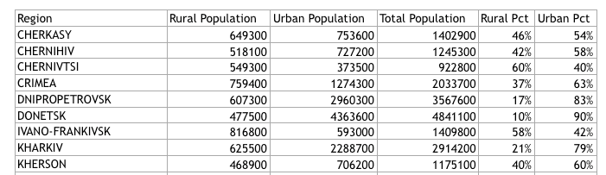
2. Percentage of the Ukraine population that have Russian as their native tongue, as of 2001, from the Ukraine Census website.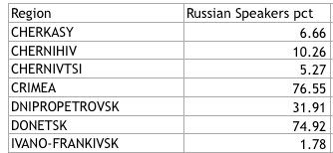

3) Ukraine population by region and education level, as of 1989. The data was obtained from the Ukraine Census website: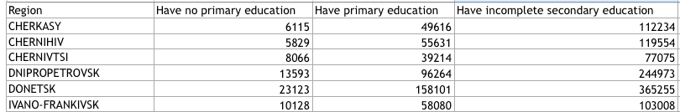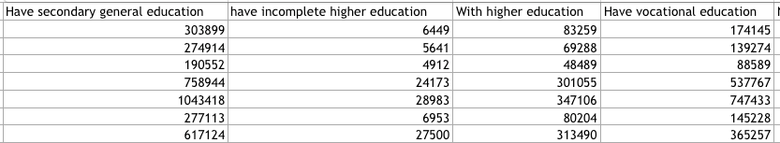

4) Ukraine population by region and source of income, as of 1989. The data was obtained from the Ukraine Census website:

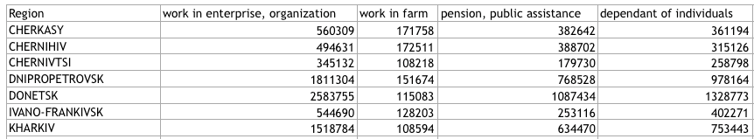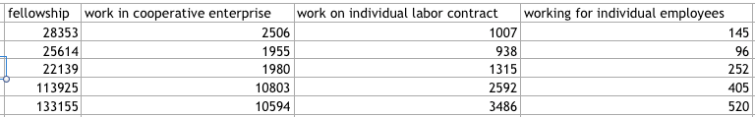

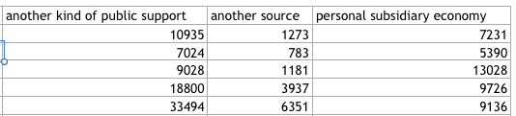

5) Ukraine population by region and nationality of income, as of 1989. For this exercise, only the Ukrainian and Russian nationalities were considered. The data was obtained from the Ukraine Census website:

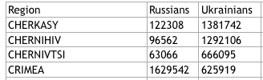

### Ukraine 2010 Presidential Elections Data

Since the Ukraine started with the removal from power of the previously elected president Viktor Yanukovych, we wish to provide the user with an underlying political map, based on the 2010 presidential elections. The source data has the same geographical grain as our main IED data set (region). Source: <https://commons.wikimedia.org/wiki/User:DemocracyATwork>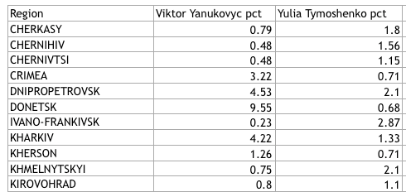

### Ukraine Map Data

We will a geojson/topojson data about the various regions of Ukraine as we expect some of this information might be displayed on a map. We have found two potentially suitable Ukraine map data files.

### Ukraine Conflict Casualties and Injuries Data

We will consider using this UN report in order to provide additional key facts about the Ukraine conflict (number of casualties and injuries by month), as well as to try to establish a relation between the number of casualties and injuries and the number if IED explosions. The data was available between 16 Feb 2015 and 15 Nov 2015. Source: <http://www.ohchr.org/Documents/Countries/UA/12thOHCHRreportUkraine.pdf>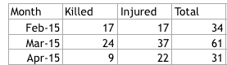

## Exploratory Data Analysis

### Tableau Data Analysis

Using Tableau, we explored the number of events, of persons killed and of persons wounded by region. The events are colored by type, which also highlights the presence of data errors like the “UNKKNOWN” label. We also explored the number of events happening in the 2014-2015 time period for each event type.

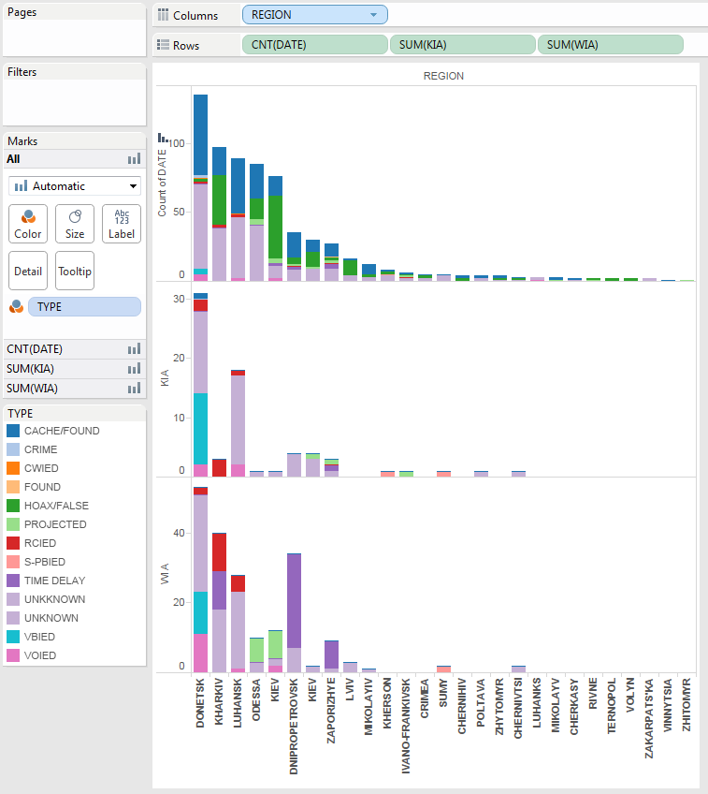

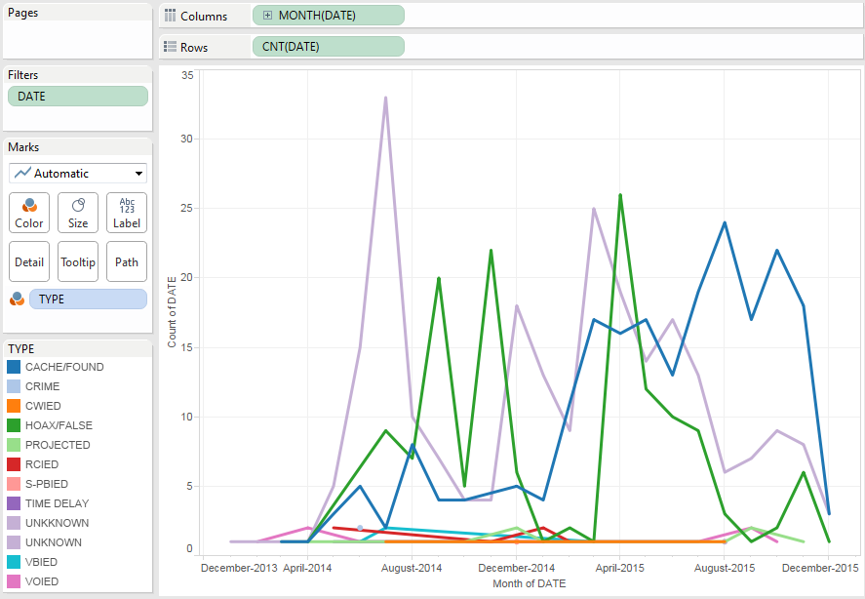

### Text Exploration

We produced a force layout to find relationships between the various IED event texts (details and remarks fields) and see the ones which have most unusual words in them.

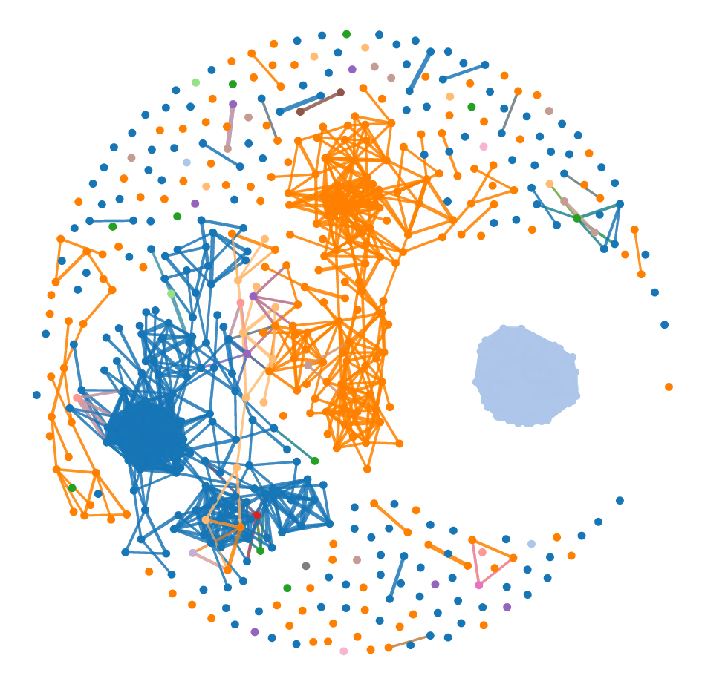

### Power BI Map

Using Power BI, we visualized the number of IED events by city and by regions.

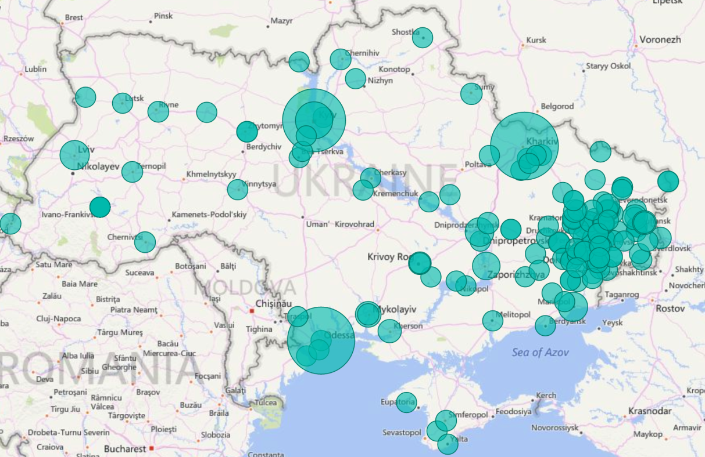

IED events by city

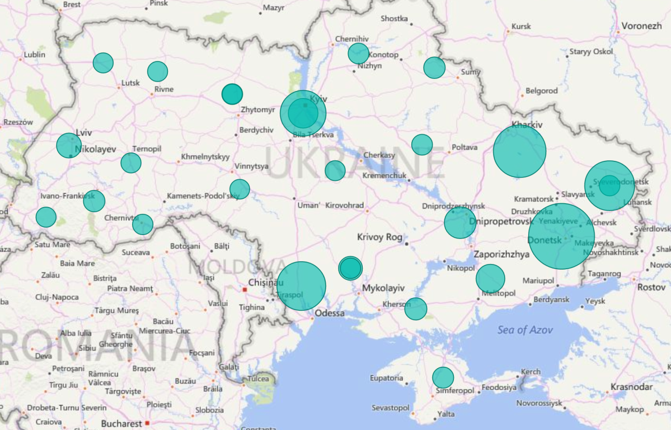

IED events by region

### Power BI Statistics

During the data collection exercise we used some graphics to explore and visualize the new dataset, as well as identify some early correlation between this dataset and the IDE dataset:

Graphical overview of the population data: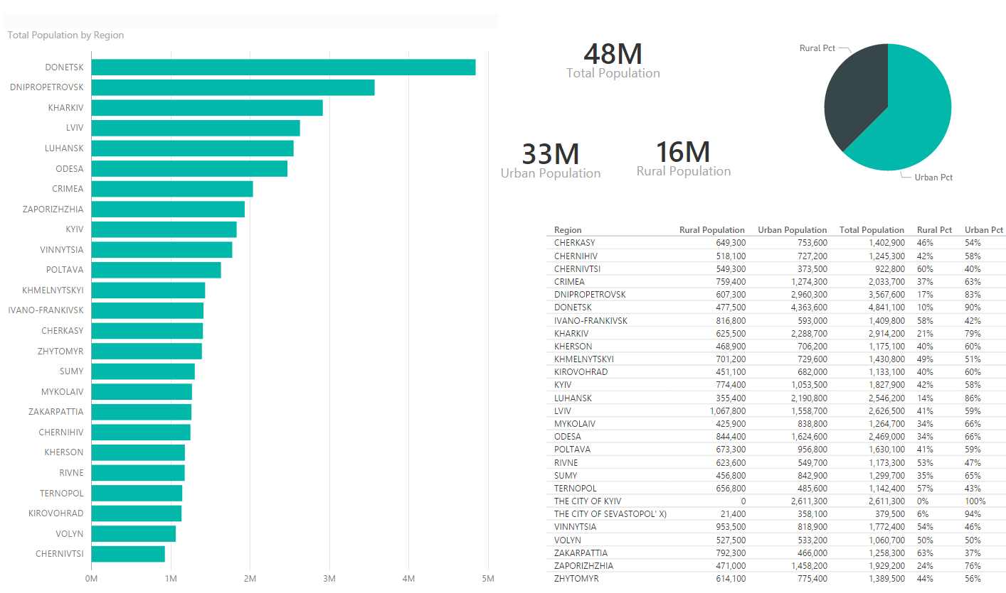

Heat map showing a potential correlation between the population of a region and the number of incidents: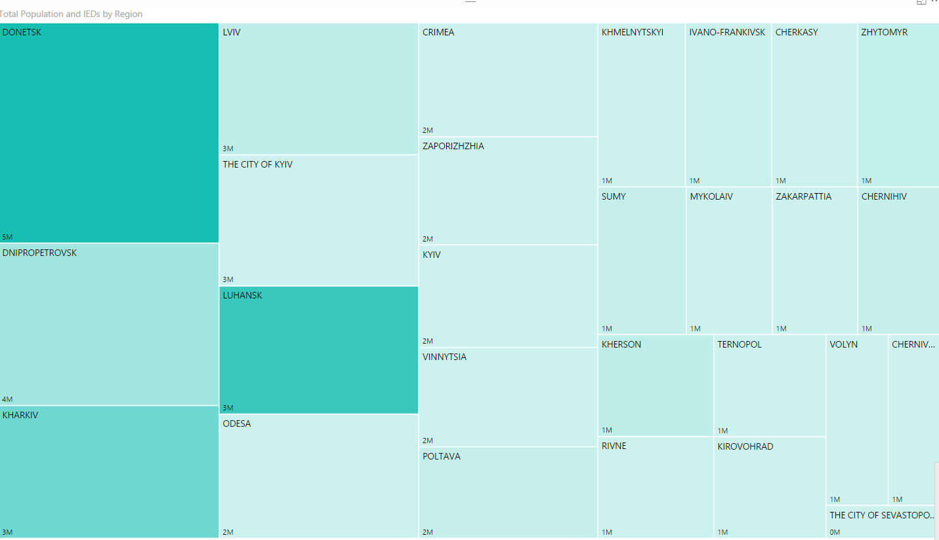

Bubble graph showing regions by number of IDEs, Population and degree of urbanization. The size of the bubbles is the fatalities resulting from the incidents.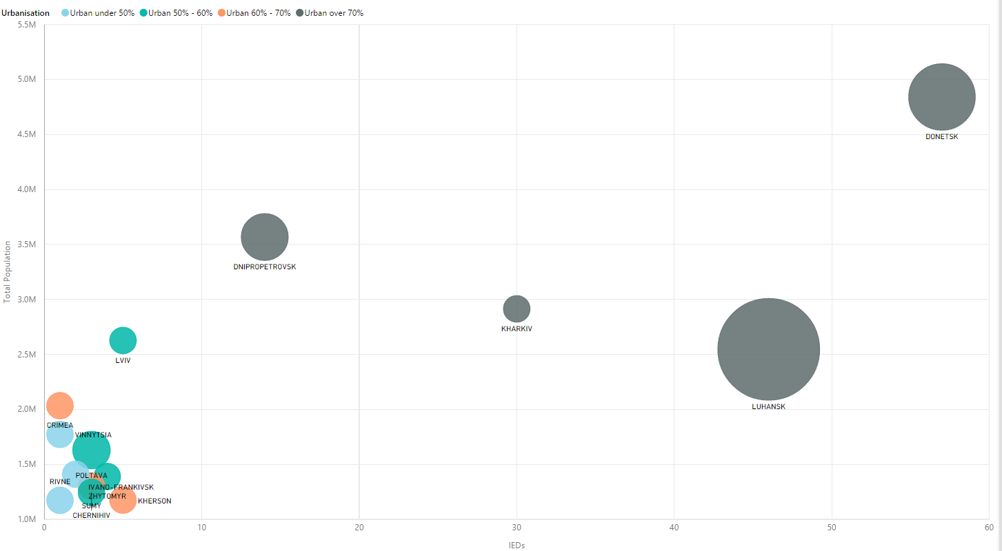

### Other Sources

Directly on the web, we found a Ukraine map showing the percentage of Russian speakers by regions. This should correspond to the data on language that is available in the Ukraine census data.

<http://www.cnn.com/interactive/2014/02/world/ukraine-divided/>

